THE SHARPSHOOTER
FORT HILL RIFLE & PISTOL CLUB NEWSLETTER
NUMBER 19 ______ _ _ ___ JANUARY, 2006

ANNUAL MEETING SCHEDULED FOR FEBRUARY 10
The annual meeting of the Fort Hill Rifle and Pistol Club (FHRPC) is scheduled for Friday, February 10, 2005, from 6 to 8 PM. The meeting will be held at the Allegany County Career Center for Technical Education on McMullen Highway. All members are encouraged to attend. If Allegany County schools are cancelled on February 10 due to weather, the annual meeting will be re-scheduled for Friday, February 17.

The major item of new business is election of club officers. Six elected officers, including a president, vice president, treasurer, two executive officers and a secretary manage your club.

CLUB OFFICERS
FHRPC officers for the year 2005 are (1) President, Wayne Belloff, 301-722-6859, (2) Vice-President, Bill Lewis, 301-777-8180, (3) Treasurer, John Dowell, 301-724-5866, (4) Executive Officer, Dave Thompson, 304-788-1346, (5) Executive Officer, Jim Soulsby, 301-724-0724, and (6) Secretary, Marty Harsh, 301-759-2877.

The club officers welcome your feedback. If you have any suggestions, comments or concerns please feel free to contact any of your club officers.

WINTER RIFLE LEAGUE
The FHRPC is conducting a rifle league this winter for anyone interested in firing classic military rifles in matches reminiscent of military qualification courses. The match schedule is shown in the following table. JCG, SPR, and RATTLE BATTLE matches are scheduled JCG matches are 30-shot matches fired at 200-yards range with the M1 Garand. SPR matches are 30-shot Springfield matches also fired at 200-yards range, but with any pre-1950, military configuration bolt-action rifle. RATTLE BATTLE matches are 64-shot rapid-fire events beginning at the 300-yard line.

The matches will be conducted at the FHRPC Warrior Mountain range. Firing will commence at 0900 (9 AM). Please arrive a minimum of 30 minutes early to allow for registration. The combined match fee is $10. The match schedule follows. Anyone desiring more information on the matches should contact Dave Thompson at 304-788-1346.

FHRPC 2006 SNOWBIRD RIFLE LEAGUE
DAY | DATE | MATCH
Sunday | January 22, 2006 | JCG/SPR
Saturday | February 11, 2006 | JCG/SPR
Sunday | February 19, 2006 | JCG/SPR
Saturday | March 11, 2006 | RATTLE BATTLE
Sunday | March 19, 2006 | RATTLE BATTLE

JUNIOR SMALLBORE RIFLE LEAGUE IN 2006
The FHRPC, in conjunction with the NRA, is again conducting the Basic Rifle Shooting Course/Rifle Shooting Merit Badge program as part of our junior smallbore rifle league. A schedule follows showing the course of instruction for this program. The course stresses firearm safety, basic knowledge of firearms and ammunition, and marksmanship skills. Students will gain experience shooting 22-caliber rimfire rifles from the shooting bench and the four basic shooting positions used in competition -- prone, sitting, kneeling and standing.

Any participant that attends five of seven lessons and demonstrates knowledge and proficiency will be recommended for a rifle shooting merit badge and will be given a certificate of completion for the course.

The FHRPC has excellent facilities, competent instructors and provides everything that is needed including rifles, ammunition, targets, hearing protection, shooting jackets, shooting mats and spotting scopes. A nominal fee of $1 is charged when shots are fired to cover target cost. This is an excellent opportunity for any youngster to become acquainted with firearms safety and to develop basic marksmanship skills at little or no cost.

Please share this information with your family, friends and neighbors. Feel free to call Chris Bennett at 301-777-2593 in the evenings for more information.

Fort Hill Rifle & Pistol Club
2006 Junior Smallbore Rifle League

NRA Basic Rifle Shooting Course/Rifle Shooting Merit Badge

OBJECT |  | Promote firearms safety & develop marksmanship skills
LOCATION |  | Morningside Drive rifle range
PARTICIPANTS |  | Boys & girls between 11 & 18 years of age. Parents are always welcome to help and frequently participate.
TIME |  | Saturdays, 9 AM to 11 AM
EQUIPMENT |  | Everything provided by FHRPC
DONATIONS |  | $1 when shots are fired
QUESTIONS |  | Call Chris Bennett at 301-777-2593 (evenings)
LESSON | DAY |  | DATE | TOPIC
1 | Saturday |  | April 01, 2006 | Rifle Knowledge & Safe Gun Handling
2 | Saturday |  | April 08, 2006 | Ammunition & Fundamentals of Rifle Shooting
3 | Saturday |  | April 15, 2006 | Firing the First Shots
4 | Saturday |  | April 22, 2006 | Prone Rifle Shooting Position
5 | Saturday |  | April 29, 2006 | Sitting & Kneeling Shooting Positions
6 | Saturday |  | May 06, 2006 | Standing Rifle Shooting Position & Review
7 | Saturday |  | May 13, 2006 | Rifle Sports & Activities

2005 ENDS WITH SIGHT-IN DAYS
2005 went out with a bang as FHRPC members helped local hunters prepare for the whitetail season. The Bubba Brigade turns out in force to support this four-day event. Shown in the following picture, from left to right, are Bubba Lewis, Bubba Fickes, Bubba Dowell, Bubba Bittner, Bubba Harsh, Bubba Knippenburg, Bubba Detrick, and Bubba Fuller. Other brigade members missing from the picture are Bubba Deter, Bubba Snyder, Bubba Frye, Bubba Detrick Jr., Bubba Soulsby, Bubba Gero, and Bubba Eastham.

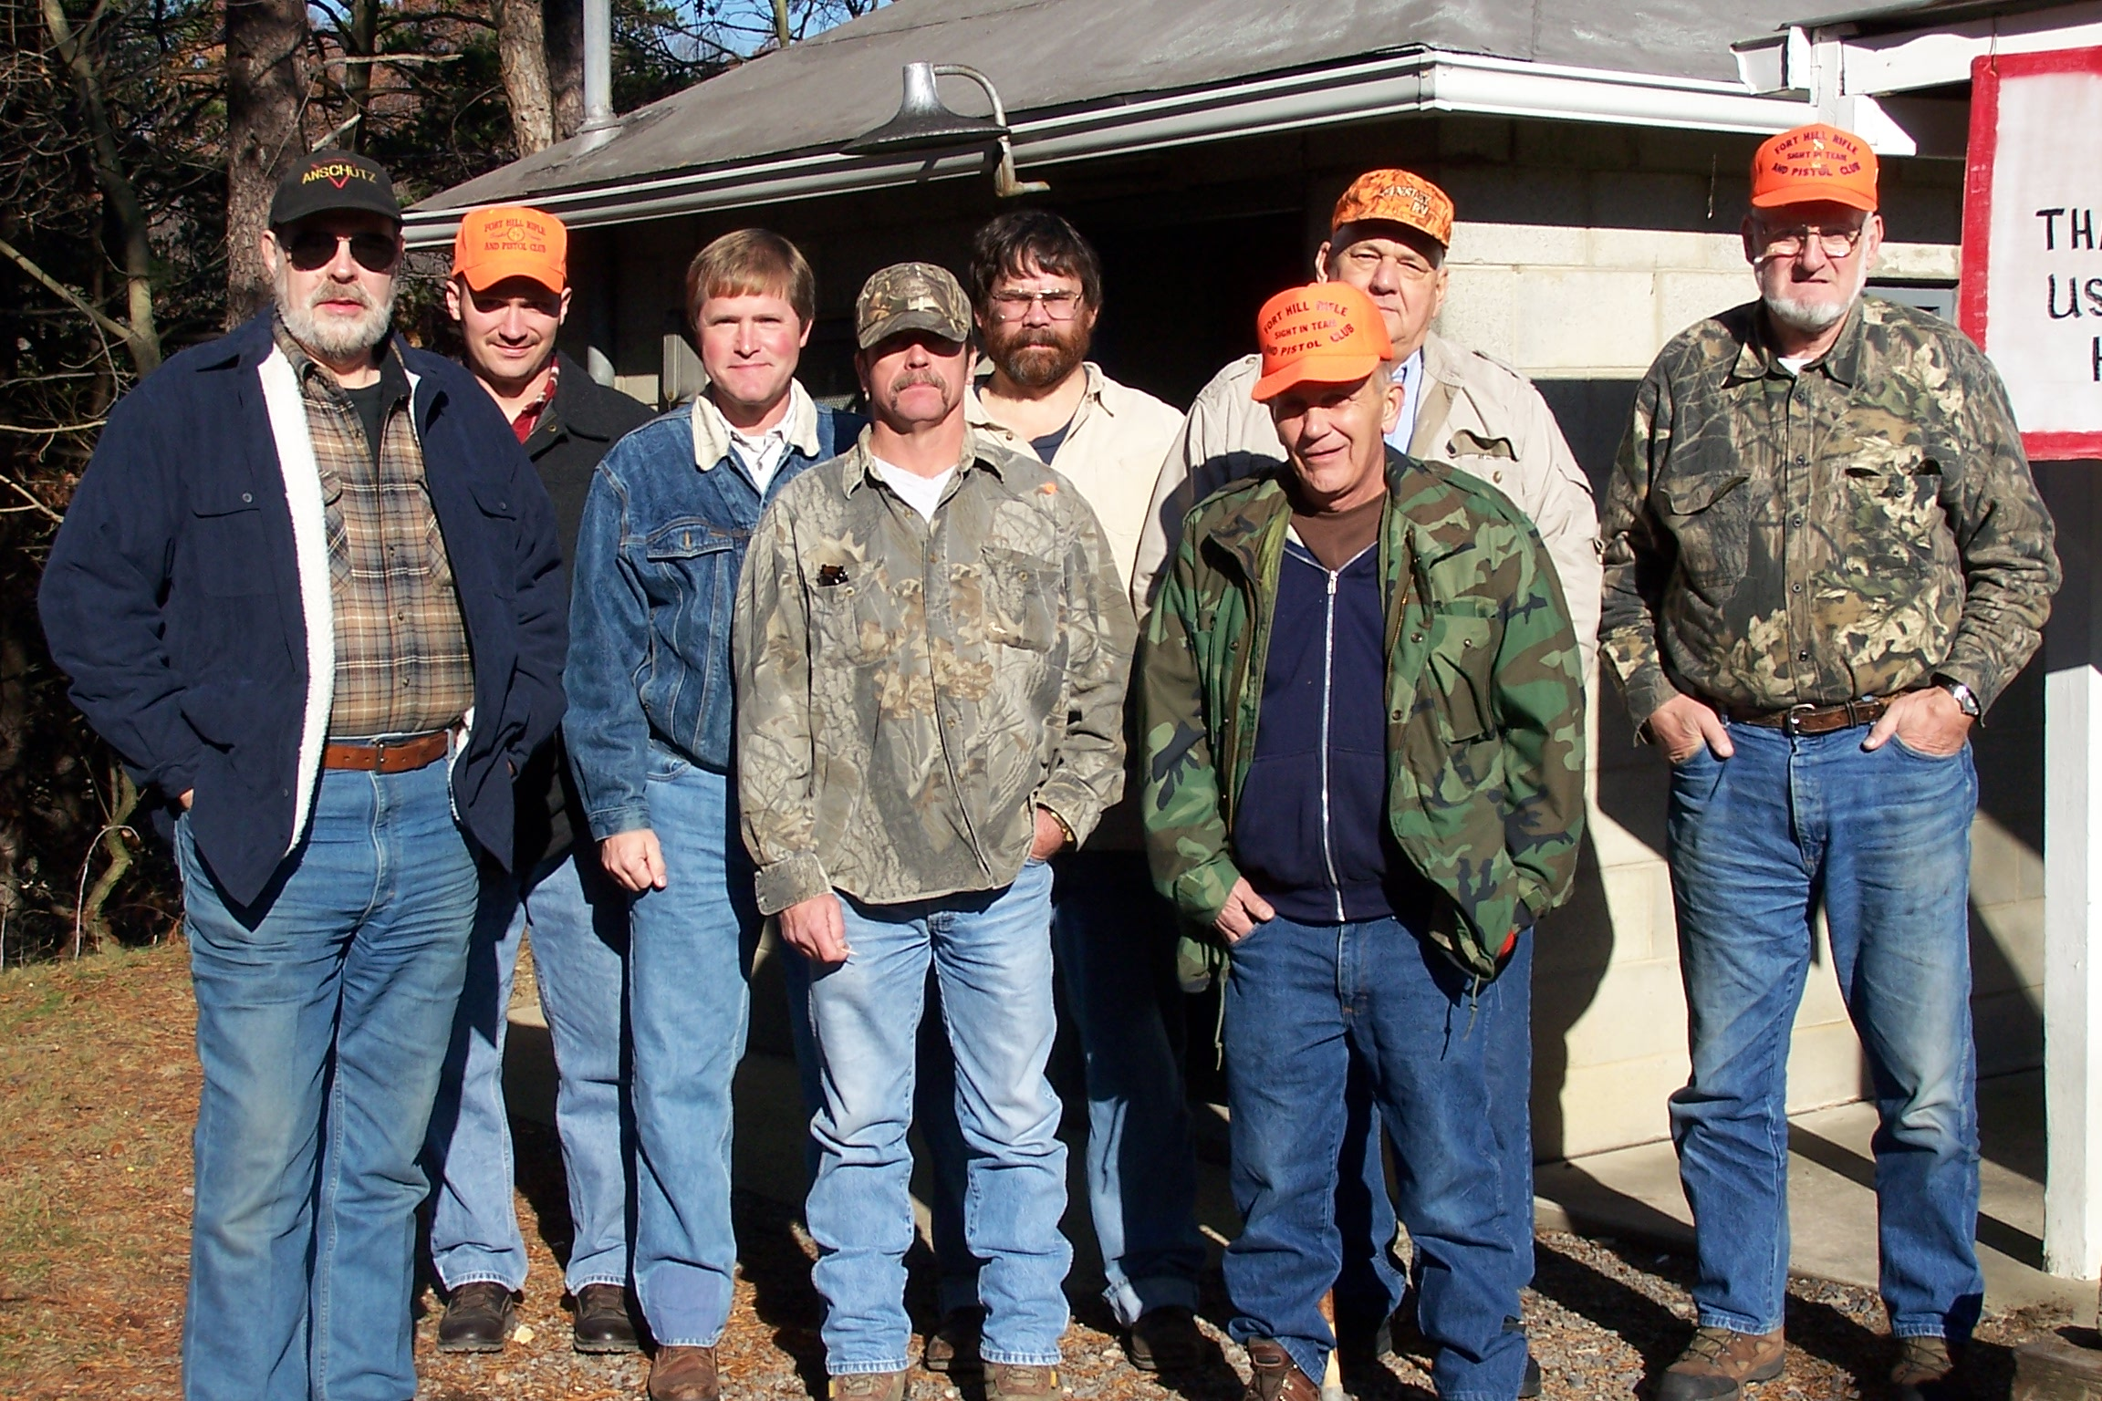

Agate smashing aside, shown in the following picture, from left to right, are Bill Lewis, Barry Fickes, John Dowell, Bill Bittner, Marty Harsh, Charlie Knippenburg, Jim Detrick, and Ken Fuller. Other brigade members missing from the picture are Ron Deter, Frank Snyder, Richard Frye, Tom Detrick, Jim Soulsby, Bill Gero, and Jon Eastham.

The FHRPC has a long history with this event. Ken Fuller, the Sight-In Team chairman, has been supporting this activity for about forty years. Fuller has retired as chairman this year. We owe our thanks to Ken for his years of dedication and support. We will need to find a replacement. Many of the other contributors have been helping for twenty years or more.

Public participation in our event was way down this year. We don’t know why and would appreciate any feedback from the general membership. Several things may be influential. The average deer hunter has much better equipment and ammo than just a few years ago. It is quite common for a shooter to fire just two or three shots to re-affirm his zero from last year. The FHRPC general membership is larger than ever. Many of our members are bringing guests to the range prior to Sight-In Days. Other nice public ranges have opened in the area. And, the publicity given to chronic wasting disease (CWD) had to discourage at least a few hunters from venturing into the woods this year. Again, we would appreciate any feedback and suggestions for improvement in next year’s event.

NEW BENCHES AT MORNINGSIDE
Range improvements have continued this year with new concrete benches at the Morningside rifle range. The plan is to replace all metal-frame benches with concrete-and-cinder block benches. The new concrete benches have integral seats, much like the older metal-frame structures. Two of the benches were completed in the early fall of 2005. With a little luck and a lot of hard work, seven more benches will be in place by the end of spring, 2006. There will still be ample room to shoot both prone and sitting while increasing the number of benches from six to nine.

The six existing metal-frame benches will be moved from Morningside to the new 100-meter range at Warrior Mountain.

Jim Soulsby and Dan Webster have been the spark plugs making this job happen. Shown in the following picture from left to right, are Jim Soulsby, Frank Snyder, and Dan Webster, when they cast the concrete tops of the new benches. Soulsby masterfully designed the two-part concrete molds to be re-useable. Webster did the metal work for the integral seat and rear post, along with the reinforcement rods. Snyder served as the mix master. A little work and ingenuity up front has made their job easier in the long run. From the grins on their faces, one must believe that they are pleased with their creation.

The final cost of the new concrete benches will be approximately $100 per bench.

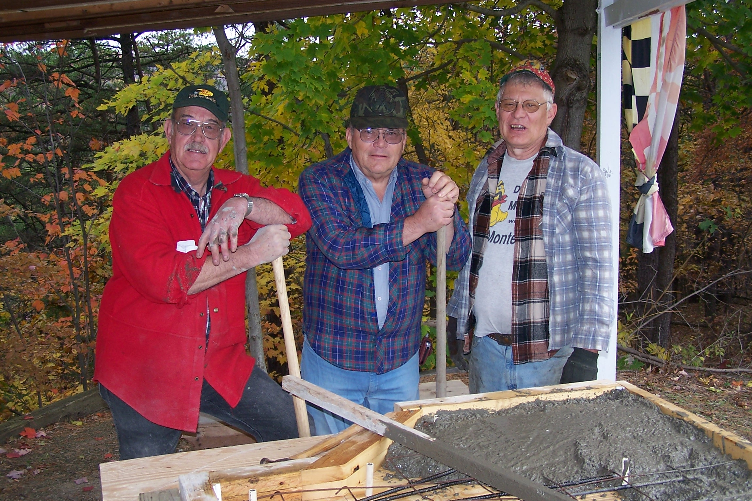

Here’s another picture of the trio at work with Snyder on the left, Soulsby in the center with the shovel, and Webster on the right dumping concrete. You new guys in the FHRPC can always identify Dan Webster as the guy with the most colorful hat, usually with a muzzleloader under his arm.

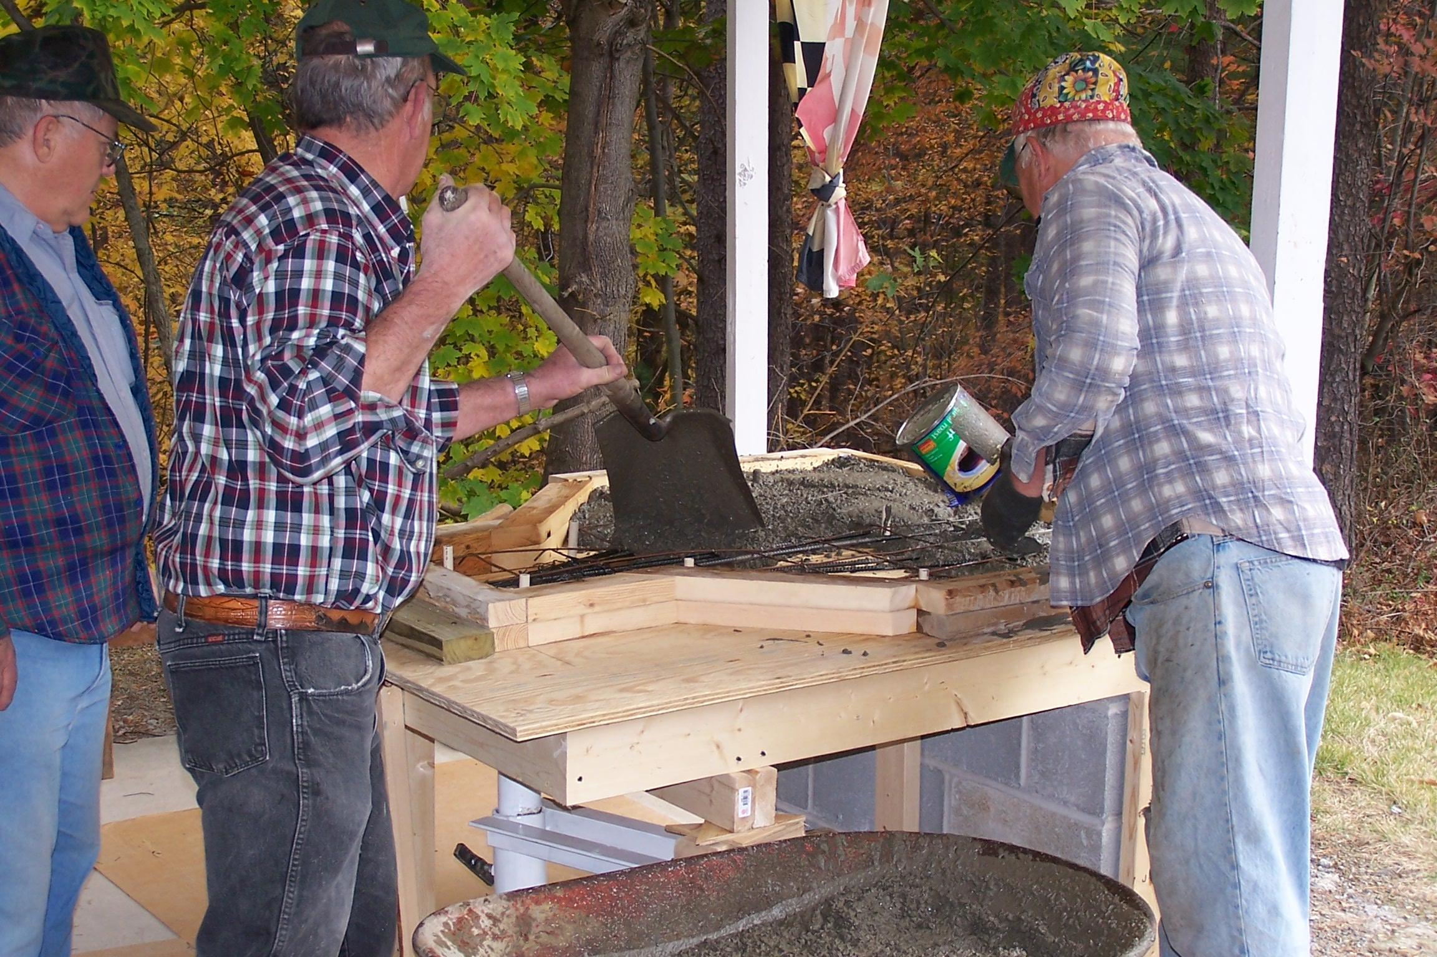

CMP OFFERING CARBINES FOR SALE

Scuttlebutt has it the Civilian Marksmanship Program (CMP) will offer M1 carbines for sale to qualified individuals in the spring of 2006. The CMP has not released any information describing the price, annual purchase limits, or the availability of carbines made by specific manufacturers.

The M1 carbine was produced during the World War 2 years in numbers greater than any other USGI service rifle up to that point in time. The NRA publication titled “U.S. Cal. .30 Carbine” list eleven carbine manufacturers, including IBM, Inland, Irwin-Pedersen, National Postal Meter, Quality Hardware & Machine, Rock-Ola, Saginaw Steering Gear of Saginaw, Michigan, Saginaw Steering Gear of Grand Rapids, Michigan, Standard Products, Underwood, and Winchester. These eleven manufacturers produced well over six million carbines in a time span of just 38 months.

The CMP has also solicited ideas for a new CMP games event, the M1 Carbine match. The M1 Carbine match match will likely be conducted like the JCG, SPR, rim-fire, and sporting rifle matches now in place.

And the M1903A3 rifles mentioned in the last newsletter – they’re gone.

TARGET PIT RENOVATED AT WARRIOR MOUNTAIN

The old railroad tie retaining wall in the target pit was removed and a new wooden catwalk installed in a major renovation project at the Warrior Mountain range in the fall of 2005. Dave Thompson served as the spark plug for this activity, designing the new catwalk and organizing the removal of the old railroad ties and walkway. Thompson is a FHRPC executive officer and serves as the highpower league chairman. The old walkway was moving away from the concrete wall several inches each year obstructing the operation of the target carriers. It had to go. A generous dose of heavy limestone rock was added to the bottom of the pit, along with drainage pipe, to eliminate the standing water problem that had also developed. Over 150 tons of material was moved in the demolition of the old wall and the new construction.

A large group of FHRPC members turned out to support his activity, along with a few non-members who participate in league shooting at the Warrior Mountain range. FHRPC members Terry Barnes, Jon Eastham, Sylvester Schultz, Don Schneider, Gary Dawson, Wayne Stott, John Dowell, Jack Parrill, Frank Snyder, Joe Lechliter, and Jim Soulsby pulled the load. Other help came from league shooters, including Mark Kane, Warren Jensen, Kirk Morris, Al Zentmyer, and Garey Diefenderfer. All of these guys gave generously of their valuable time to improve our range. Special thanks go to Terry Barnes, who again donated the use of his tractor.

Shown in the following picture, from left to right, are Dave Thompson, Jon Eastham, and Sylvester Schultz. The new walkway is cantilevered off the concrete wall. These fellows are standing on 100 tons of limestone added to the bottom of the pit to improve drainage.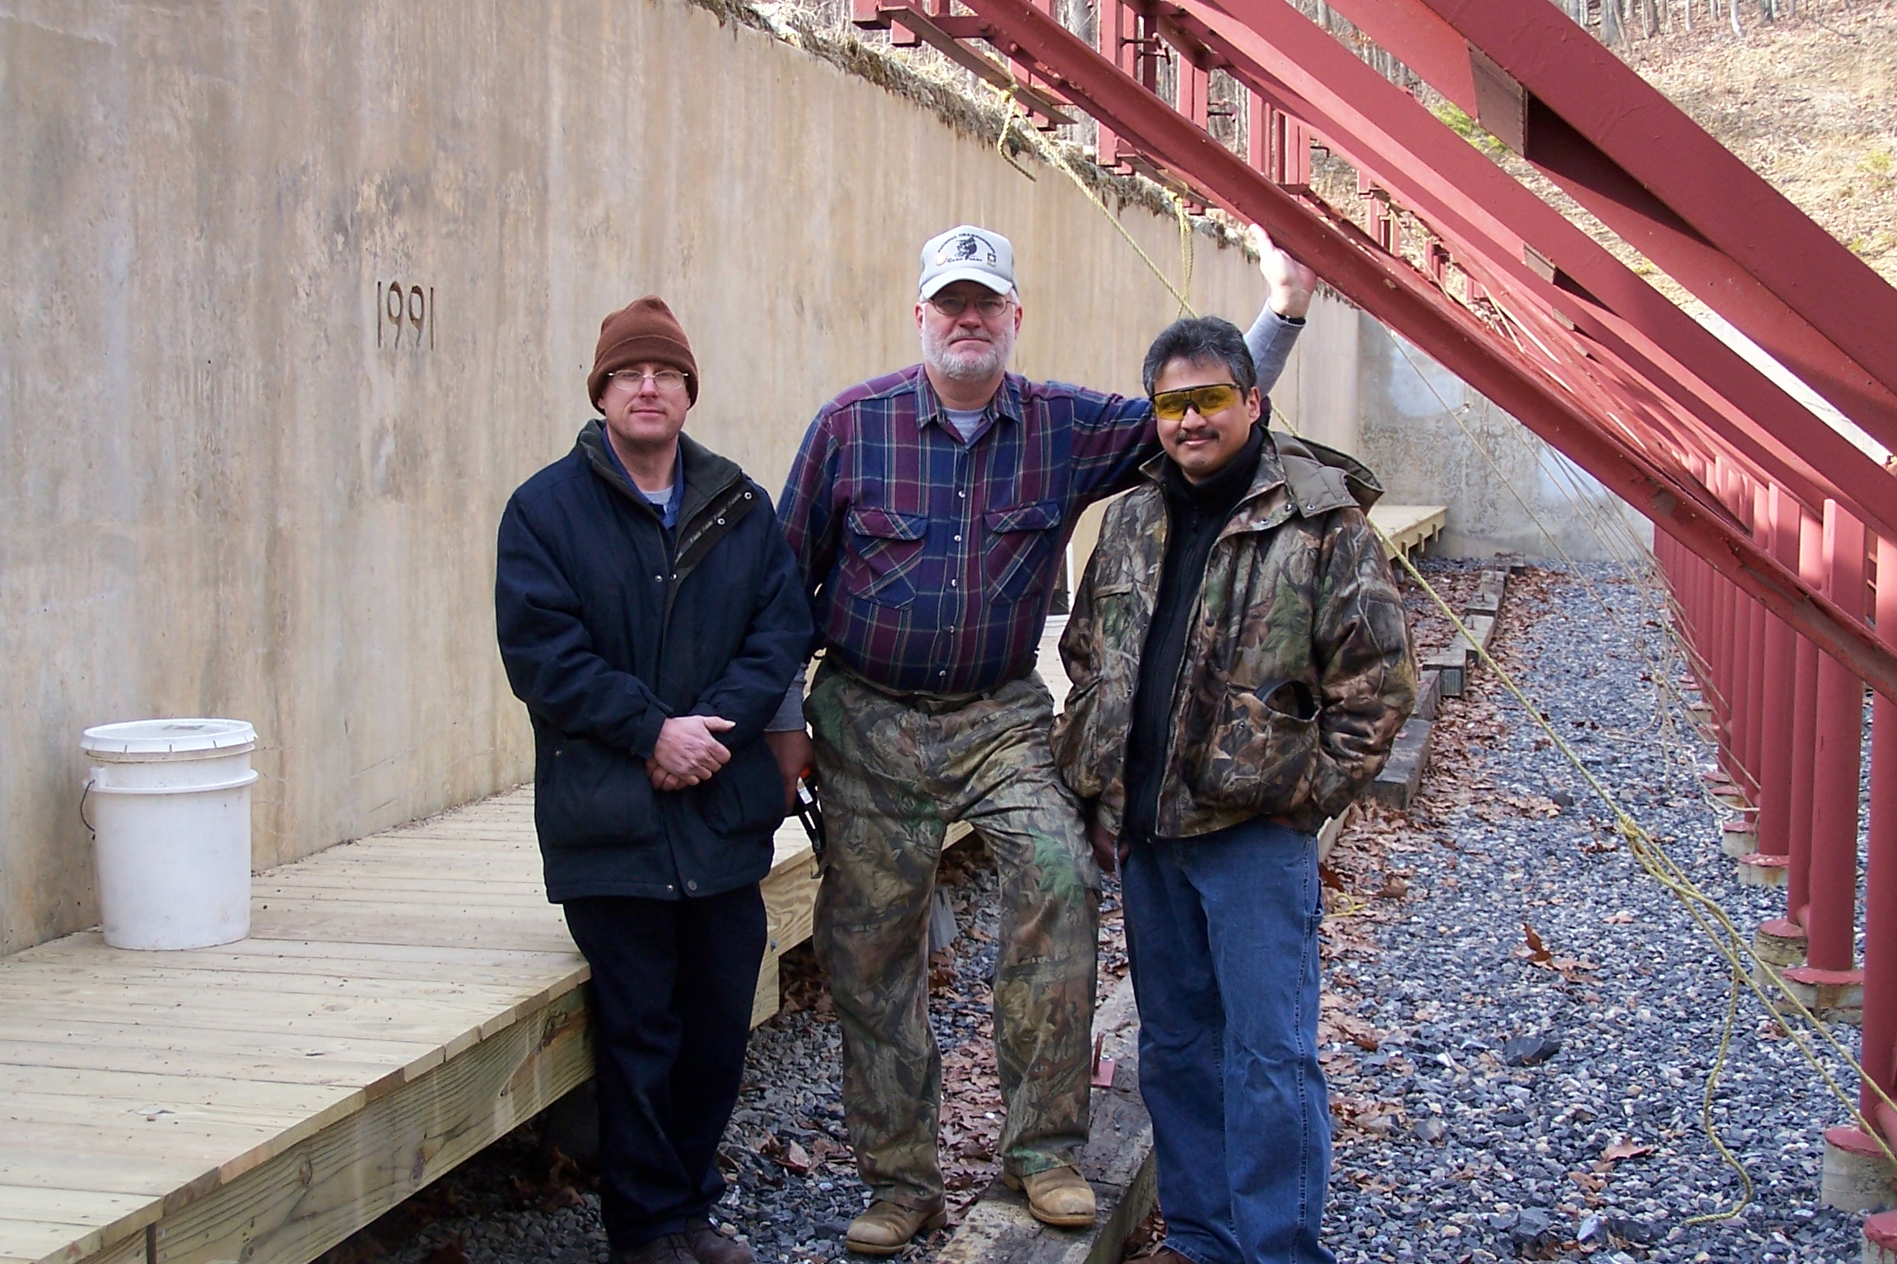

LONACONING TRAP CLUB IN TIGHT SPOT
You have probably seen some of the front-page news in the Cumberland Times describing legal action brought against the Lonaconing Trap Club (LTC) for noise pollution. Legislation was passed in the 2005 Maryland General Assembly exempting sport shooting ranges in western Maryland from noise regulations. Most, if not all, western Maryland clubs with shooting ranges supported the legislation at the request of the LTC. The legislation was passed but, for some reason, the LTC was cleverly left out of the protection. The LTC boys did the leg work but have not enjoyed any of the benefit. Their fate is still in the wind.

A ruling against the LTC may have a negative impact on all shooting ranges in Allegany, Washington, and Garrett counties.

The LTC has asked for our help one more time.

A phone call or a letter to our local Maryland legislators would be a big help. Simply convey to our representatives that you would like their help in achieving a favorable result for the LTC and assurance that there will not be any future action brought by the Maryland Department of the Environment against sport shooting ranges in western Maryland. Do not underestimate the power of your phone call or letter. The FHRPC is a large group of voters and can have a big impact in future elections.

- John J. Hafer, Senator, District 1
James Senate Office Building, Room 323
110 College Avenue
Annapolis, MD, 21401-1991
Phone: (local) 301-689-4666, (Annapolis) 1-800-492-7122, extension 3565

- Kevin Kelly, Delegate, District 1B
Lowe House Office Building, Room 320
84 College Avenue
Annapolis, MD, 21401-1991
Phone: (local) 301-777-9000, (Annapolis) 1-800-492-7122, extension 3404

- George C. Edwards, District 1A
Lowe House Office Building, Room 320
84 College Avenue
Annapolis, MD, 21401-1991
Phone: (local) 301-895-5720, (Annapolis) 1-800-492-7122, extension 3435

- LeRoy E. Myers Jr., Delegate, District 1C
Lowe House Office Building, Room 320
84 College Avenue
Annapolis, MD, 21401-1991
Phone: (local) 301-722-0926, (Annapolis) 1-800-492-7122, extension 3435

WANTED TO BUY, SELL OR TRADE
This section of the FHRPC newsletter is reserved for membership advertising. You can advertise your surplus sporting gear for sale (WTS, want to sell) or trade (WTT, want to trade). Likewise, if you are looking for something to buy (WTB, want to buy), you can advertise here. Sporting gear can be any type of shooting, archery, hunting, fishing, or camping equipment. Examples include firearms, ammo, reloading equipment and components, scopes, bows, boots, portable tree stands, and tents. Forward your advertisements to Marty Harsh at 313 Sunset Drive, LaVale, Maryland, 21502, for the next newsletter.

The FHRPC is not responsible for any sales, lack thereof, or compliance with any federal, ATF, state, or local regulations.

- WTS, Thompson-Center Renegade muzzleloading rifle, 54 cal, with two barrels, first barrel with one turn-in-66 inches for round ball, second barrel with one turn-in-28 inches for conical projectiles, includes some 54-cal accessories, and Thompson-Center White Mountain carbine, 50 cal, with one turn-in-28 inches barrel for conical projectiles, includes some 50-cal accessories, $100 each, or $150 for both, Jon Eastham, 301-724-2560.
- WTS, M91/30 and M38 Mosin-Nagant rifles, 7.62X54R, includes 200 rounds milsurp ammo, both rifles in very good condition, M91/30 very accurate, $200 for pair, Jon Eastham, 301-724-2560.
- WTS, WW2 K98k German Mauser, 8MM, BNZ41, vet bring back, miss-matched bolt, everything else matches, Nazi eagle proof marks, excellent condition, $350, Jon Eastham, 301-724-2560.
- WTS, Turkish Mauser, 8MM, very accurate, very good condition, $125, Jon Eastham, 301-724-2560.
- WTS, arrows, too many to list, POR, Frank Snyder, 301-777-1289.
- WTS, arrow shaft cutting machine, POR, Frank Snyder, 301-777-1298.
- WTS, bullet puller, with complete set of collets, POR, Frank Snyder, 301-777-1298.
- WTS, Walther, 22-cal pistol, model KSP200, molded righthand grip, with 100 rounds Eley ammo, like new, $650, Pete Walsh, 301-724-0841.
- WTS, Iver Johnson, revolver, break action, 5-shot, 32 cal, antique, $125, Carol Lennox, 301-729-0461.
- WTS, Remington, semi-auto shotgun, model 1100, 12 GA, 2 ¾-inch chamber, skeet barrel, $265, Carol Lennox, 301-729-0461.
- WTS, trigger shoe for handgun, $5 each, Ken Fuller, 301-724-5254.
- WTS, Remington, model 700BDL, 270WIN, left hand, like new, $400, Ken Fuller, 301-724-5254.
- WTS, 22X13 arrows, model XX75, 27.5-inch long, with knocks, inserts and vanes, $3 each, Ken Fuller, 301-724-5254.
- WTS, Remington, model 700BDL, bolt action rifle, heavy barrel, 222 REM, beautiful stock, 9-18X Simmons scope with 40-mm objective, Lee & RCBS reloading dies, 1350+ rounds ammo loaded with 50-grain Hornady bullets, 25-grain VARGET powder, Federal 205 primers, in two 50-cal cans, all for $700, George Sneathen, 301-759-1323.
- WTS, Savage model 93 bolt action rifle, 17HMR, bull barrel, match trigger, 2 magazines, 40-mm 3-9X Burris mil-dot scope, 22+ boxes Hornady and CCI ammo, 50-mm 20X Burris spotting scope, cleaning rod, cleaning snake, cleaning rod guide, cleaning brushes, cleaning patches, gun case, all for $600, George Sneathen, 301-759-1323.
- WTS, M1 Garand stock and handguards, new, walnut, made by Boyd’s, may require some minor fitting around trigger group, no stock metal, $82, Marty Harsh, 301-759-2877.
- WTS, 30-cal projectiles, 174-g USGI FMJBT, new, not pulled, $16/100, $75/500, Marty Harsh, 301-759-2877.
- WTS, 30-cal projectiles, 174-g USGI FMJBT, inertia pulled from de-milled ammo, no pull marks, $11/100, $50/500, Marty Harsh, 301-759-2877.
- WTS, 30-06 brass, once fired, de-primed, polished, LC69 head stamp, $6/100, $25/500, Marty Harsh, 301-759-2877.
- WTS, 30-06 brass, once fired, de-primed, polished, WCC56 head stamp, $6/100, $25/500, Marty Harsh, 301-759-2877.
- WTS, 303 British brass, once fired, de-primed, polished, HXP73 head stamp, $6/100, $25/500, Marty Harsh, 301-759-2877.
- WTS, 303 British brass, once fired, de-primed, polished, HXP76 head stamp, $6/100, $25/500, Marty Harsh, 301-759-2877.
- WTS, 30 carbine brass, once fired, polished, mixed head stamps, all USGI, 2000+ pieces, $25, Marty Harsh, 301-759-2877.
- WTS, 308 brass, once fired, de-primed, polished, Federal, from Gold Medal match ammo, $6/100. Marty Harsh, 301-759-2877.
- WTS, Marbles Game Getter, model 21, 22 RF over 410 GA shotgun, with shoulder stock, original holster, mahogany storage box, $1700, Cliff Bennett, 304-788-3890.
- WTS, Clark target pistol, 45ACP, M1911 frame, 6-inch barrel, smithed by Jim Clark, Shreveport, LA, $1000, Harry Twigg, 814-634-1516.
- WTS, Pardini target pistol, 45 cal, 6-inch barrel, red-dot sight, $1000, Harry Twigg, 814-634-1516.
- WTS, Remington, model 700 Varmint Synthetic, 223 REM, left hand, new in box, never fired, price reduced to $580, Barry Miller, 301-777-3532.
- WTS, McMillan fiberglass stock for M14/M1A, model M1A, green/woodland camo, new in box, reduced to $300, Barry Miller, leave message at 301-777-3532.
- WTS, Winchester, model 67, 22 rimfire, single shot, bolt action, $125, Wayne Belloff, 301-722-6859.
- WTS, Enfield No. 1 MK III*, 303 British, somewhat sporterized, $150, Wayne Belloff, 301-722-6859.
- WTS, US model 1896 Krag-Jorgensen bolt action service rifle, 30-40 KRAG, sporterized, beautiful bluing, $300, Wayne Belloff, 301-722-6859.
- WTS, Lee Pacesetter reloading dies, 7MM REM MAG, decapper, resizer, bullet seater, factory crimp, all in plastic case, like new, $15, Russ Lease, 301-729-0365.
- WTS, 6.5MM Jap brass, new, unfired, Norma manufactured, box of 20 pieces, $10, Jim Gift, 301-359-3639.
- WTS, 7X57MM reloading dies, Hornady, $10, Jim Gift, 301-359-3639.
- WTS, 6.5MM JAP reloading dies, Lee, $10, Jim Gift, 301-359-3639.
- WTS, 300 WIN MAG, Lyman, $10, Jim Gift, 301-359-3639.
- WTS, Winchester model 69 22-rimfire barrel, can also be used on model 75, new, $25, Jim Gift, 301-359-3639.
- WTS, gun books, Complete Guide to Handloading by Phil Sharpe, The Rifle in America by Phil Sharpe, The Amateur Gun Craftsman by James Howe, Modern Gunsmith by James Howe, Custom Rifles by Dick Simmons, Reprinted Old Gun Catalogs by L. D. Saterlee, Americans and Their Guns by NRA Publications, Treasury of the Gun by Harold Peterson, $150 for all, Jim Gift, 301-359-3639.
- WTS, 308 WIN blanks, Austrian manufacture, $1.50 per box of 20, have 5 boxes, Jack Parrill, 304-738-9270.
- WTS, 223 REM blanks, M200, USGI, $3.65 per box of 20, have 50 boxes, Jack Parrill, 304-738-9270.
- WTS, Thompson Center muzzleloading rifle, percussion lock, White Mountain model, very good condition, $125, Chuck Laurie, 301-777-1383.
- WTS, Federal Ordnance M1A, 308 WIN, new Barnett match barrel, fired less than 100 rounds, $700, Tom Langley, 301-689-6869.
- WTS, Norinco M1A, 308 WIN, fired less than 50 rounds, $700, Tom Langley, 301-689-6869.
- WTS, handmade hunting knives, made to order, some in stock, call for prices, Mike Carney, 301-777-0997.
- WTS, Savage, M110, left hand, 7MM REM MAG, like new, with 3-9X scope, $370, Darrel Bailey, 301-777-0551.
- WTB, sporterized M1903A3 rifle, complete, Bill Murphy, 301-334-8550.
- WTB, M1903A3 receiver and bolt, Bill Murphy, 301-334-8550.
- WTB, hicket steel M1903 receiver and bolt, Bill Murphy, 301-334-8550.
- WTB, IMR 1-pound powder cans, empty, $1 each, Marty Harsh, 301-759-2877.
- WTB, 12-gauge shotgun shell reloader, Roger Winebrenner, 301-689-6426.
- WTB, Smith&Wesson, model 686, Tom Langley, 301-689-6869.

THE MASTER & HIS ACCOMPLISHED STUDENT

We wanted to show you one more picture -- from our 3rd Annual Raffle, showing activity at the muzzleloader match. On the left is Uncle Fred Krieger. Terry Mulligan is on the right. Mulligan has won more muzzleloader championships than we have space to mention here. The National Muzzle Loading Rifle Association (NMLRA) ranks Mulligan as one of the best in the country. Krieger is the FHRPC muzzleloader league chairman, and the guy who taught Mulligan how to shoot the smoke pole.

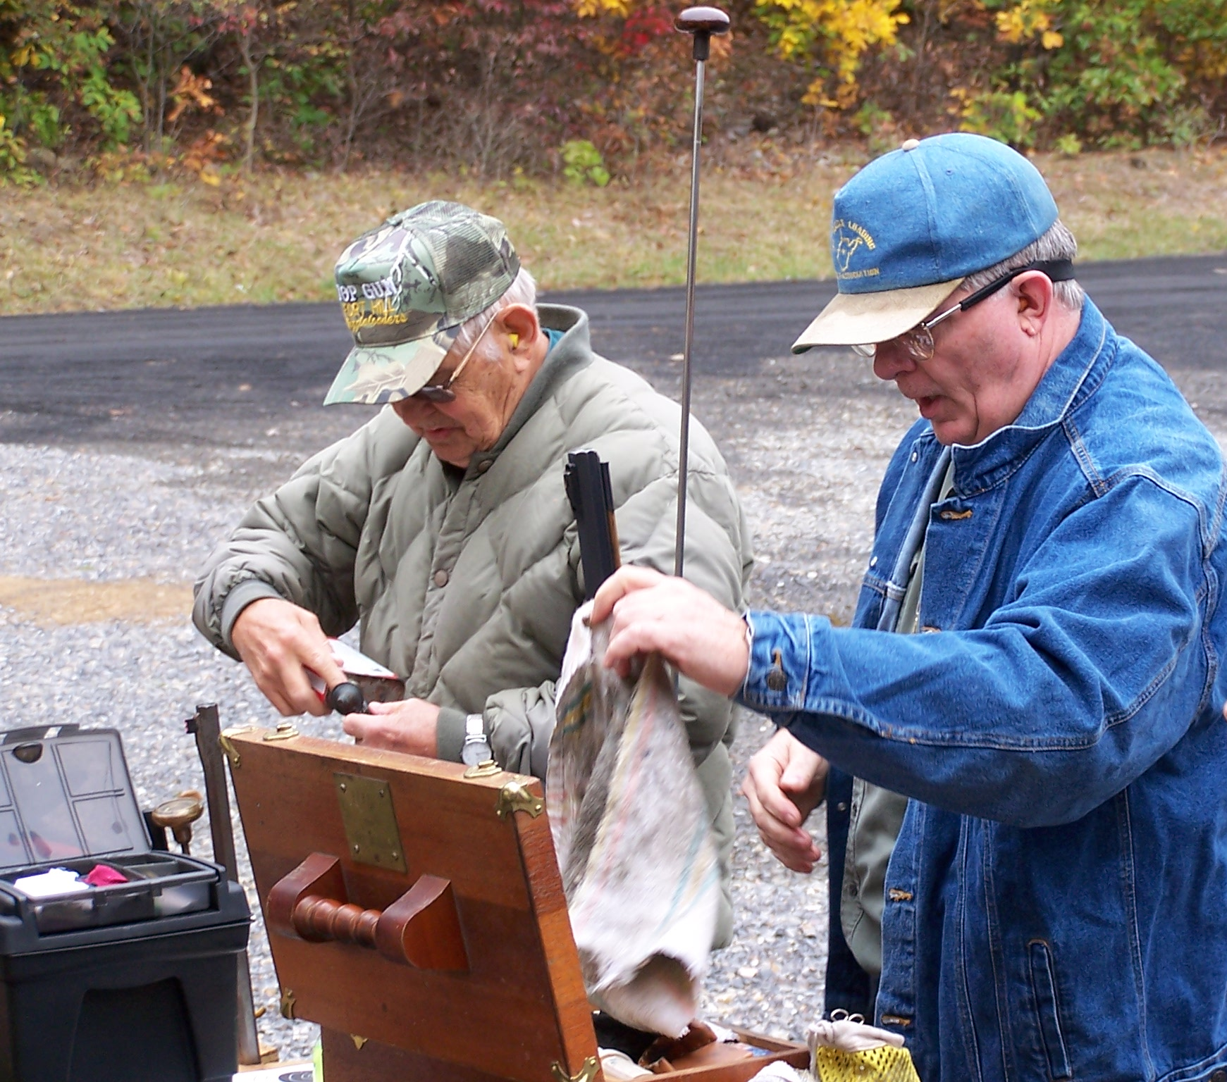

PLACES TO SHOOT
This section of the FHRPC newsletter is reserved for information describing shooting matches outside the FHRPC and in the not-to-distant surroundings. If you know of other places holding shooting matches that might be of interest to the FHRPC membership, forward the information to Marty Harsh at 313 Sunset Drive, LaVale, Maryland, 21502, for the next newsletter.

Action Pistol
- Frostburg, MD, Longview Shooting Range, defensive pistol matches, similar to IDPA, 10 AM, Apr 30, May 21, Jun 18, Jul 16, Aug 20, Sep 17, Oct 22, George Gallagher, 301-463-6264, Tom Thrasher, 301-689-2868, Tom Langley, 301-689-6869.

Bench Rest
- Grantsville, MD, Casselman Valley Sportsmen’s Club, bench rest, 22 rimfire, unlimited, any scope, any rifle, 25 yards, indoors, Sundays, 1 PM, Jan 22, 29, Feb 5, 12, 19, 26, Mar 12, 26, 301-895-3373.
- Grantsville, MD, Casselman Valley Sportsmen’s Club, bench rest, 22 rimfire, unlimited, any scope, any rifle, 25 yards, indoors, Thursdays, 7 PM, May 4, 11, 18, 25, Jun 1, 8, 15, 22, 29, Jul 6, 13, 20, 27, Aug 3, 10, 17, 31, Sep 7, 14, 21, 28, 301-895-3373.
- Grantsville, MD, Casselman Valley Sportsmen’s Club, bench rest, center fire, factory rifle, sporter barrel, 24-power scope limit, Saturdays, 1 PM, Mar 4, 18, Apr 1, 15, 29, May 6, 20, 27, Jun 3, 17, Jul 15, 29, Sep 9, 23, Oct 7, 21, Nov 4, 18, 301-895-3373.

Muzzleloader
- Maysville, WV, first Sunday of each month, $10 per match, starts at 1 PM, Terry Mulligan at 304-738-3219.

Highpower Rifle
- Allemans, PA, Reade Range, Pennsylvania State Rifle & Pistol Association home range, for detailed info see WWW.READERANGE.ORG, or call Tom Ferraro, 724-352-0234.
- Allemans, PA, Reade Range, RK Nelson match + cook out, 50-shot National Match course, 200, 300, 600 yards, Sep 17, Tom Ferraro, 724-352-0234.
- Allemans, PA, Reade Range, 80-shot Regional course, 200, 300, 600 yards, Apr 23, May 21, Jun 3, 17, Jul 23, Aug 27, Oct 22, Tom Ferraro, 724-352-0234.
- Allemans, PA, Reade Range, LEG match, 200, 300, 600 yards, Jun 4, Jul 9, Tom Ferraro, 724-352-0234.
- Allemans, PA, Reade Range, Pennsylvania state highpower rifle championship, 2-day event, 1st day regional course, 200, 300, 600 yards, 2nd day 600 yards, Jun 24, 25, Tom Ferraro, 724-352-0234.
- Allemans, PA, Reade Range, Pennsylvania state servcie rifle championship, regional course, 200, 300, 600 yards, Jul 8, Tom Ferraro, 724-352-0234.
- Allemans, PA, Reade Range, 600-yard match, two 20-shot strings, Apr 22, May 20, Jun 11, Jul 22, Sep 16, Oct 15, Tom Ferraro, 724-352-0234.
- Allemans, PA, Reade Range, 1000-yard match, three 20-shot strings, Apr 9, May 7, Jul 2, Sep 3, Oct 8, Tom Ferraro, 724-352-0234.
- Allemans, PA, Reade Range, sniper match, 60 shots, May 6, Sep 2, Tom Ferraro, 724-352-0234.
- Allemans, PA, Reade Range, long range day, two 20-shot strings at 600 yards, two 20-shot strings at 1000 yards, Sep 2, Tom Ferraro, 724-352-0234.
Smallbore Rifle
  - Grantsville, MD, Casselman Valley Sportsmen’s Club, bench rest, 22 rimfire, unlimited, any scope, any rifle, 25 yards, indoors, Sundays, 1 PM, Jan 22, 29, Feb 5, 12, 19, 26, Mar 12, 26, 301-895-3373.
  - Grantsville, MD, Casselman Valley Sportsmen’s Club, bench rest, 22 rimfire, unlimited, any scope, any rifle, 25 yards, indoors, Thursdays, 7 PM, May 4, 11, 18, 25, Jun 1, 8, 15, 22, 29, Jul 6, 13, 20, 27, Aug 3, 10, 17, 31, Sep 7, 14, 21, 28, 301-895-3373.
Sporting Clays
- Everett, PA, Everett Sportsmen’s Club, P. O. Box 312, Everett, PA, 15537, 50-bird rounds, shooting from 10 AM to 3:30 PM, food & ammo available, Ed Sponsler, 814-652-5562.
Trap
- Lonaconing, MD, Lonaconing Trap Club, Tuesday & Thursday evenings starting at 4 PM, Saturday mornings starting at 10 AM, $2.50 per round (25 birds), Gary Dawson, 814-356-3688.
- Bedford, PA, Bedford Sportsmen’s Club, every Wednesday at 4 PM, $2.50 per round (25 birds), Gary Dawson, 814-356-3688.
- Grantsville, MD, Casselman Valley Sportsmen’s Club, trap, Sundays, 1 PM, Mar 5, 19, Apr 2, 16, 30, May 7, 21, Jun 4, 18, 25, Jul 16, 30, Aug 6, Sep 10, 24, Oct 8, 22, Nov 5, 19, 23, 301-895-3373.
- Grantsville, MD, Casselman Valley Sportsmen’s Club, trap, Calcutta and Lewis events, trap, Saturdays, 1 PM, Feb 11, Mar 11, Apr 8, May 13, Jul 8, Aug 12, Sep 16, Oct 14, 301-895-3373.

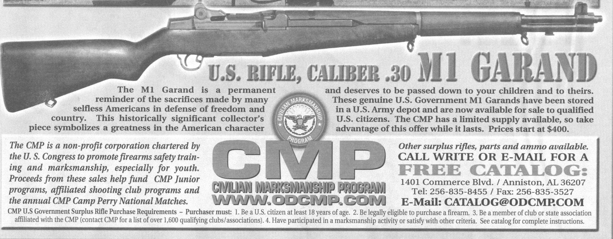

MAILING LABEL SHOWS MEMBERSHIP STATUS
Your mailing label on the newsletter envelope shows your membership status.

If the letter N or N+ appears in parentheses appears after your name, (N) or (N+), you joined the FHRPC after December 31, 2000, and must maintain NRA membership as a prerequisite to FHRPC membership. N+ identifies you as an NRA life member.

If the letter L appears in parentheses appears after your name, (L), you are a life member in the FHRPC. Your membership is dues free.

If there is no letter in parentheses after your name, you joined the FHRPC before January 1, 2001, and have not yet achieved life membership.

